Bag Price Prediction
Code Explanation — Lab 1 (main.ipynb)
Random Forest Regressor | Python | scikit-learn

Cell 1 — Import Libraries
This cell loads all the Python libraries needed for the project before any other code runs.

import pandas as pd
import numpy as np
import matplotlib.pyplot as plt
from sklearn.model_selection import train_test_split
from sklearn.ensemble import RandomForestRegressor
from sklearn.metrics import mean_absolute_error
from sklearn.preprocessing import LabelEncoder
import warnings
warnings.filterwarnings('ignore')
pd.set_option('display.max_columns', None)

- pandas — used to load and work with the CSV data as a table (DataFrame)
- numpy — provides numerical operations like arrays and math functions
- matplotlib.pyplot — used to create charts and graphs
- train_test_split — splits the data into training and validation sets
- RandomForestRegressor — the main ML model used to predict bag prices
- mean_absolute_error — measures how accurate the model's predictions are
- LabelEncoder — converts text categories (like 'Brand') into numbers
- warnings.filterwarnings('ignore') — hides unimportant warning messages
- pd.set_option('display.max_columns', None) — shows all columns when printing a DataFrame

screenshot :
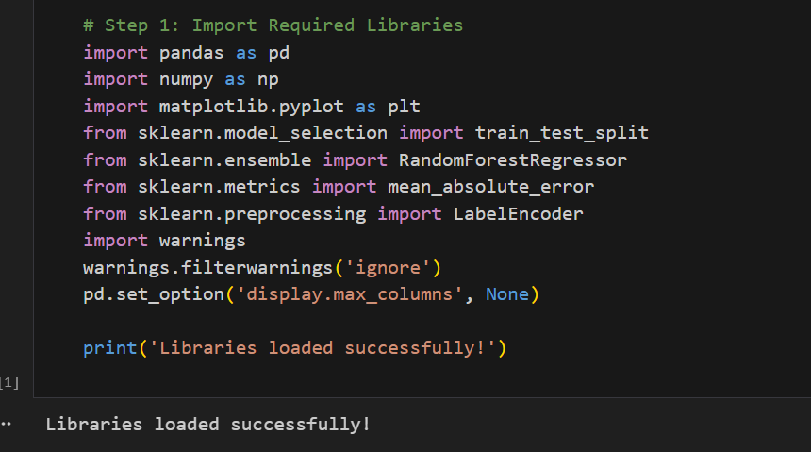

Cell 3 — Load the Dataset
This cell reads the CSV file from disk and prints basic information about its shape and column names.

df = pd.read_csv('Noisy_Student_Bag_Price_Prediction_Dataset.csv')
print(f'Dataset shape: {df.shape}')
print(f'Columns: {df.columns.tolist()}')

- pd.read_csv() reads the CSV file and stores it in a variable called df (DataFrame)
- df.shape returns (rows, columns) — tells you how big the dataset is
- df.columns.tolist() prints the name of every column in the dataset

Cell 4 — Preview the Data
This single line displays the first 5 rows of the dataset so you can visually inspect what the data looks like.

df.head()

- df.head() shows the first 5 rows by default
- Useful for quickly checking if the data loaded correctly and understanding the column values

Cell 5 — Check Missing Values & Price Summary
This cell checks if any column has missing (null) values, and then prints a quick summary of the target column Price.

print(df.isnull().sum())

target_col = 'Price'
print(f'Average : ${df[target_col].mean():.2f}')
print(f'Min : ${df[target_col].min():.2f}')
print(f'Max : ${df[target_col].max():.2f}')

- df.isnull().sum() counts how many missing values are in each column
- target_col = 'Price' stores the name of the column we want to predict
- .mean(), .min(), .max() calculate the average, lowest, and highest price in the dataset
- :.2f formats the number to 2 decimal places (e.g., $85.50)

Cell 6 — Plot Price Distribution
This cell creates a histogram chart to visually show how bag prices are distributed across the dataset.

fig, ax = plt.subplots(figsize=(10, 5))
ax.hist(df['Price'].dropna(), bins=50, color='steelblue', edgecolor='white')
ax.set_xlabel('Bag Price ($)', fontsize=12)
ax.set_ylabel('Count', fontsize=12)
ax.set_title('Distribution of Bag Prices', fontsize=14)
plt.tight_layout()
plt.show()

- plt.subplots(figsize=(10, 5)) creates a blank figure that is 10 inches wide and 5 inches tall
- ax.hist() draws the histogram — bins=50 means the price range is divided into 50 bars
- .dropna() removes any rows with missing Price values before plotting
- set_xlabel, set_ylabel, set_title add labels and a title to the chart
- plt.tight_layout() prevents labels from being cut off
- plt.show() renders and displays the chart

Cell 8 — Clean Data & Encode Categories
This cell removes rows with missing values and converts all text-based columns into numbers so the model can use them.

df_clean = df.dropna().reset_index(drop=True)

cat_cols = ['Brand', 'Material', 'Size', 'Laptop Compartment',
'Waterproof', 'Style', 'Color']
le_dict = {}
for col in cat_cols:
le = LabelEncoder()
df_clean[col] = le.fit_transform(df_clean[col])
le_dict[col] = le

- df.dropna() removes every row that has at least one missing value
- reset_index(drop=True) resets row numbers after rows are removed
- cat_cols is a list of all columns that contain text (categorical) values
- LabelEncoder converts text labels to integers: e.g. 'Red'=0, 'Blue'=1, 'Green'=2
- le.fit_transform(col) learns the mapping and applies it to the column in one step
- le_dict saves each encoder so the same mapping can be reused later if needed
Screenshot:

Cell 10 — Define Features & Split Data
This cell separates the data into input features (X) and the target price (y), then splits everything into training and validation sets.

target_col = 'Price'
feature_cols = [c for c in df_clean.columns if c != target_col]

X_all = df_clean[feature_cols]
y_all = df_clean[target_col]

X_tr, X_val, y_tr, y_val = train_test_split(
X_all, y_all, test_size=0.2, random_state=42
)

- feature_cols is a list of every column except Price — these are the model's inputs
- X_all contains all input features; y_all contains only the Price column (the answer)
- train_test_split divides the data: 80% for training, 20% for validation (test_size=0.2)
- random_state=42 ensures the split is the same every time the code runs
- X_tr / y_tr = training data; X_val / y_val = validation data used to test accuracy

Cell 12 — Train the Random Forest Model
This cell creates a Random Forest model with specific settings and trains it on the training data.

rf_model = RandomForestRegressor(
n_estimators=100,
max_depth=10,
min_samples_split=5,
random_state=42
)

rf_model.fit(X_tr, y_tr)

- RandomForestRegressor() creates the model with the given settings
- n_estimators=100 — the model builds 100 separate decision trees
- max_depth=10 — each tree can have at most 10 levels deep (prevents overfitting)
- min_samples_split=5 — a node must have at least 5 samples before it can split
- random_state=42 — makes results reproducible across runs
- rf_model.fit(X_tr, y_tr) — trains the model using the training features and prices

Cell 14 — Evaluate Model Accuracy
This cell uses the trained model to predict prices on the validation set and measures how far off the predictions are.

val_predictions = rf_model.predict(X_val)
mae_score = mean_absolute_error(y_val, val_predictions)
avg_price = y_val.mean()

print(f'Validation MAE : ${mae_score:.2f}')
print(f'Avg Validation Price : ${avg_price:.2f}')
print(f'MAE as % of Average : {mae_score/avg_price*100:.2f}%')

- rf_model.predict(X_val) generates price predictions for the validation set
- mean_absolute_error(y_val, val_predictions) calculates the average dollar error between actual and predicted prices
- A lower MAE means the model is more accurate
- MAE as % of Average shows the relative error — e.g. 5% means predictions are off by 5% on average

Cell 15 — Actual vs Predicted Plot
This cell creates a scatter plot comparing actual prices to the model's predicted prices. Points close to the red diagonal line mean good predictions.

fig, ax = plt.subplots(figsize=(8, 6))
ax.scatter(y_val, val_predictions, alpha=0.3, color='teal', s=15)
mn, mx = y_val.min(), y_val.max()
ax.plot([mn, mx], [mn, mx], 'r--', lw=2, label='Perfect Prediction')
ax.set_xlabel('Actual Price ($)')
ax.set_ylabel('Predicted Price ($)')
ax.set_title('Actual vs Predicted Bag Prices')
ax.legend()
plt.show()

- ax.scatter() plots each validation sample as a dot (actual price on X-axis, predicted on Y-axis)
- alpha=0.3 makes dots semi-transparent so overlapping points are visible
- ax.plot([mn, mx], [mn, mx], 'r--') draws a red dashed diagonal line — this is the perfect prediction line
- If a dot lies exactly on that line, the prediction was 100% correct
- Dots far from the line indicate larger prediction errors

Cell 16 — Feature Importance
This cell shows which features had the most influence on the model's price predictions, displayed as a horizontal bar chart.

importance_df = pd.DataFrame({
'Feature': feature_cols,
'Importance': rf_model.feature_importances_
}).sort_values('Importance', ascending=False)

fig, ax = plt.subplots(figsize=(8, 5))
ax.barh(importance_df['Feature'][::-1], importance_df['Importance'][::-1], color='coral')
ax.set_xlabel('Importance Score')
ax.set_title('Feature Importance - Random Forest')
plt.show()

- rf_model.feature_importances_ is an array of scores showing how much each feature contributed to predictions
- sort_values('Importance', ascending=False) orders features from most to least important
- ax.barh() draws a horizontal bar chart — longer bar = more important feature
- [::-1] reverses the order so the most important feature appears at the top of the chart

Cell 18 — Final Model & Submission File
This cell retrains the model on the full cleaned dataset (not just the 80% training split) for best accuracy, then generates predictions on the test data and saves them to a CSV file.

final_rf = RandomForestRegressor(
n_estimators=100, max_depth=10, min_samples_split=5, random_state=42
)
final_rf.fit(X_all, y_all)

df_test = pd.read_csv('test.csv')
X_test_final = df_test[feature_cols]
test_preds = final_rf.predict(X_test_final)

output_df = pd.DataFrame({'Id': range(1, len(test_preds)+1), 'Price': test_preds})
output_df.to_csv('submission.csv', index=False)

- final_rf.fit(X_all, y_all) trains on ALL available data (100%) for the best possible model
- pd.read_csv('test.csv') loads the held-out test data whose prices are unknown
- df_test[feature_cols] selects only the same input columns used during training
- final_rf.predict(X_test_final) generates predicted prices for every row in test.csv
- pd.DataFrame({'Id': ..., 'Price': ...}) builds the submission table with an ID and a predicted price per row
- output_df.to_csv('submission.csv', index=False) saves the final predictions to a CSV file

Lab 1 — Bag Price Prediction | Code Documentation

